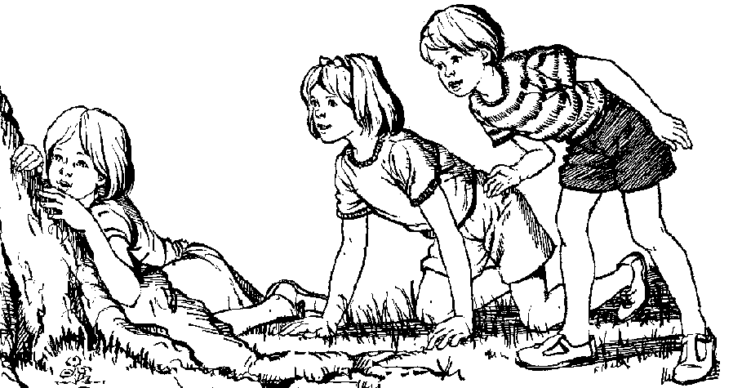

The ***I-Search*** paper is a visual representation of the process that people go through when they want to learn more about a topic. For example, pretend you are 20 years old and you have been saving to buy a car for years. The time has come to buy that car and you want to make a good purchase. There are several cars you like and you know a little bit about each model, but you need to learn more before you give over your hard earned money to any dealer. What do you do?

Well chances are you begin by talking to various people with some expertise. They may include people who own the models you are interested in or they may be mechanics that you trust and you know have a great deal of knowledge about cars in general. As you speak to these people, they may offer suggestions, raise new questions, or possibly send you to other resources to find your answers. Perhaps, you will learn that a used model might be better than a new model, which might send your search in a slightly different direction. Perhaps you will speak with people at a credit union or a bank that will help you to finance this purchase.

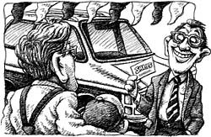

From there, you might consult magazines such as Consumer Reports or Car and Driver that can offer evaluations and information on the models you are interested in. You might do a search on the web and find information on websites or read blogs on the topic of cars, and specifically on the models you’re interested in purchasing.

Finally, you might visit a dealership and review the brochures and take the cars for a test drive. You would probably engage in a conversation with the car salesman who will educate you on the specifics of the model, all along recognizing that this person’s objective is to sell you a car. (Remember, perspective and agenda is important to the value you place on information and how you interpret that information).

In the end, you will make a decision on a specific model, and there will be specific reasons why you have made the choice you made. You will now be the proud owner of your first car. But, you will have gained more than just a car in this process. Along this journey of inquiry you will have learned much about not only the models of cars you were considering, but about cars and the process of buying cars that you did not know before the search, information that will serve you well in the years to come.

Believe it or not, that’s research. Education has managed to formalize this process so well that all the fun of an inquiry has been sucked out of the search and most students find themselves dreading research assignments. Because I believe the search for knowledge should be joyful, I have decided that our research paper will be more authentic than the more traditional formal model. We will be writing an ***I-Search*** paper, one in which the story of the discovery is essential to the writing.

**Here’s what you need to know about *I-Search* papers:**

1. The ***I-Search*** paper acknowledges that good research comes from a personal desire to learn something. Therefore ***it is essential*** that you choose a topic about which you are passionate and anxious to learn more.
2. The ***I-Search*** paper recognizes that the learning takes place in the context of the learner. Therefore, much of the paper is written in first-person and your opinion and judgment of the information you discover is an integral part of the process and the paper.
3. You already know something about the topic you are researching and that information is important to the context of the search. You will need to record this knowledge.
4. All research, even buying a car, begins with a question. You will need to identify the guiding questions for your research, keeping flexible enough to know that as you gain more knowledge, you may develop more questions or refine your old ones.
5. In real life, you begin almost all research with conversations. Conversations with people who know something about your topic are essential for your ***I-Search*** paper. You will be required to conduct an interview with an expert on your topic as one of the required sources.
6. Experts write books, articles and websites and you need to know what the experts who spend much of their time learning about your topic have to say about that topic.
7. Eventually, you will come to the end of your search and you will need to share with your reader what you have come to learn.
8. You will need to record all the sources of information you used in your search in a bibliography.

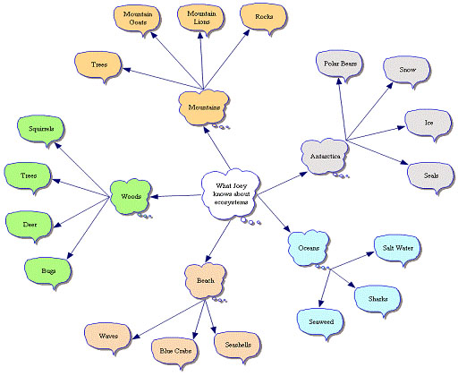**The Format of your paper will be:**

1. **What I Know -** This is where you begin with one or two paragraphs about what you already know about your topic. Include not only what background you have in this topic, but any experiences you have had and tell where and how you came to know this information. Share why you are curious about learning more about this topic. The information here does not need to be accurate. In fact, we can learn a great deal from the assumptions we hold that we later discover are not grounded in truth. So, remember it is important you be honest here, not necessarily correct.



1. **What I Want to Know** – You will then write one or two paragraphs in which you present the questions you desperately want to have answered about your topic by your research. While you will have a number of questions about your chosen topic, there will be ***one main guiding research question*** that will need my approval before you are permitted to begin your research. This is the most critical piece of any research as the questions you write will frame and guide your search. They will direct you to your sources and keep you focused throughout the process. This process will take more time than you think, so make sure you allot the time to do it will. You will add this to your What I Know section and submit as one paper.
2. **Research Journey/Annotated Bibliography** This section will consist of separate summaries of three out of your required minimum of six sources. You will begin by putting the source into MLA work cited format. The first paragraph will describe for the reader how you found and vetted the source. After carefully reading the source, you will then summarize for the reader the pertinent information from that source, taking care to connect that information to the questions you have identified in the *What I Want to Know* section. You will also include in this section questions that arise because of any new information you may have discovered in the source. After you have summarized the information, you will conclude by sharing your opinion of the perspective/s and information presented in the source. You are required to have at least one interview/conversation, one article or book, and one website, for a total of three different stories.
3. **What I Learned** – In this section, you reflect on the entire search and synthesize what you have learned, the questions you have answered as well as questions that were raised. This section will shift to a more formal writing format, moving from 1st person to 3rd person. It will include an introduction in which you share the thesis (often the guiding question rephrased into a statement) that directed your research. You will then write several paragraphs (*organized around ideas, NOT SOURCES)* in which you share with your reader not only what you learned, but also how that new knowledge has changed your thinking about the topic. You will need to support your new learning with evidence pulled from your sources and cite those sources in your text. You will finish this section with a powerful conclusion that clearly summarizes your newfound knowledge, emphasizing its importance.



1. 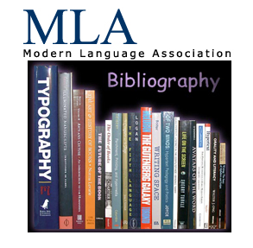**Reflection** – In this final paragraph you will shift back to 1st.You will describe your thoughts about your journey and demonstrate how you have grown as a learner and a researcher through this process.
2. **Works Cited** – Here’s where you list the sources you’ve used for your paper according to MLA guidelines. All sources from your Research Journey must be listed along with any other sources that you cited in your paper. A minimum of six sources must be listed.