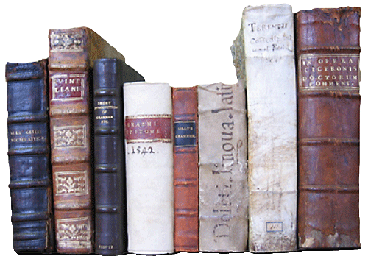
Name: _______________________

RECORD OF BOOKS READ
2015-2016
TITLE | AUTHOR | # OF PAGES | DATE BEGUN | DATE FINISHED  / ABANDONED | FICTION  NON-FICTION | TEXT COMPLEXITY  HOLIDAY; JUST RIGHT; CHALLENGES | RATING
 |  |  |  |  | F / NF | H JR C
 |  |  |  |  | F / NF | H JR C
 |  |  |  |  | F / NF | H JR C
 |  |  |  |  | F / NF | H JR C
 |  |  |  |  | F / NF | H JR C
 |  |  |  |  | F / NF | H JR C
 |  |  |  |  | F / NF | H JR C
 |  |  |  |  | F / NF | H JR C
 |  |  |  |  | F / NF | H JR C
 |  |  |  |  | F / NF | H JR C
 |  |  |  |  | F / NF | H JR C
 |  |  |  |  | F / NF | H JR C
 |  |  |  |  | F / NF | H JR C
 |  |  |  |  | F / NF | H JR C
 |  |  |  |  | F / NF | H JR C
 |  |  |  |  | F / NF | H JR C
 |  |  |  |  | F / NF | H JR C
 |  |  |  |  | F / NF | H JR C
 |  |  |  |  | F / NF | H JR C
 |  |  |  |  | F / NF | H JR C
 |  |  |  |  | F / NF | H JR C

