Name____________________________________________ Week 13 Vocabulary Study Guide
Word Bank: midwife diminutive adroit dexterous conclusive

- Were the test results from your doctor _________________________, or is there more testing that needs to be done?
- She stayed home and had the baby using a ______________________ instead of going to the hospital with a doctor.
- An ___________________________ sculptor can turn a lump of clay into an object of great beauty.
- A successful plumber must have ____________________________ hands.
- The archaeologists found ___________________________ proof that a dinosaur bigger than any other on record existed, and they call it Argentinosaurus.
- My granddaughter’s American Girl doll was a __________________________ version of her.
- President Obama is a/an _______________________ leader who can persuade people with his ideas of democracy.
- My ___________________________ husband always says “I’m tall on the inside.”
- Although she historically handled almost all pregnancies and baby deliveries, during the 20th century there has been a rise of conflict and at times opposing views between the choice of a ___________________________ or a doctor.
Word Bank: conventional, facetious, pompous, comely, obscure
- My husband would have preferred something much more sporty than our __________________ minivan.
- The ___________________________ house was set back behind lots of trees, which made us uncomfortable that dark starless night.
- The ___________________________ students were dressed so nicely for their 8th grade pictures.
- Although students intend for their side comments or remarks to be ______________________, teachers often see them as a distraction and an interruption.
- Many feel that Donald Trump’s wealth and success have led him to be a very
_______________________________ individual.

Which suffix/prefix/root?
15. to look or see ___________________
16. down ___________________
17. man ___________________
18. all, every ___________________
19. relating to, quality ___________________
20. father ___________________

Vocab Memes – due (tomorrow) go to imgflip.com
- create memes using this week’s vocab words
- all must be school-appropriate
- all must show understanding of the word’s proper definition
- save your memes in a Google doc
- Share the document with me
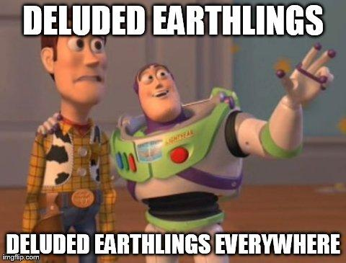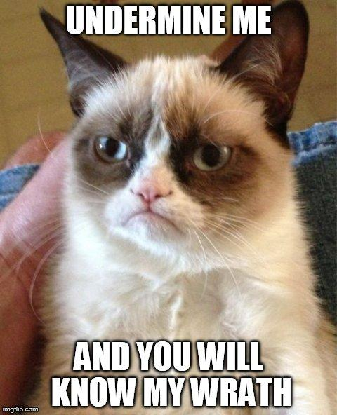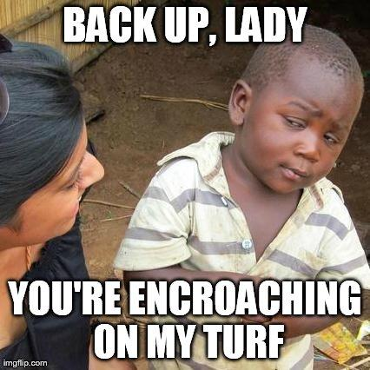

For each word in the box, illustrate its meaning:
Dexterous | Proximity
Omniscient | Impunity

